**RESULT**

**Results:**

The motive of our project is to convert the raw data into pictorial representation without installing any desktop application.It provides online data analysis without storing any data.It helpful in identifying patterns in the data.It gives better representation to the row data and it is easy to understand.The basic objective of the project to provide the free online platform for Data Analysis.The main aim of our project is to convert the available cluttered data into a format which is easy to understand, more legible, conclusive and which supports the mechanism of decision-making. In this project we also explore different methods in python which helps for data analysis.

Our Website is able to accept the file from the user for data analysis .This Website is able to satisfy user expectations such as showing pictorial representation of the data such as bar chart , time series , pie chart , and so on.

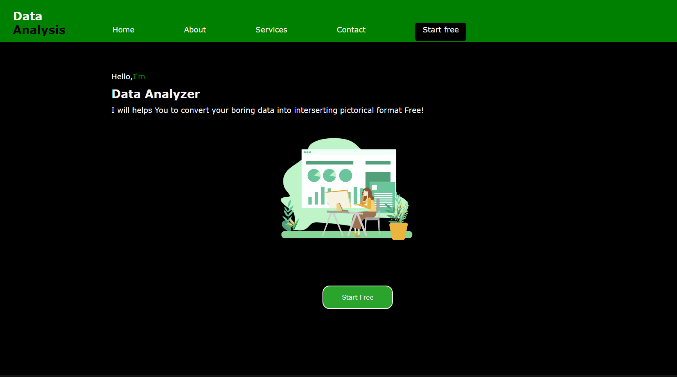

Front Page for Home (index.html)

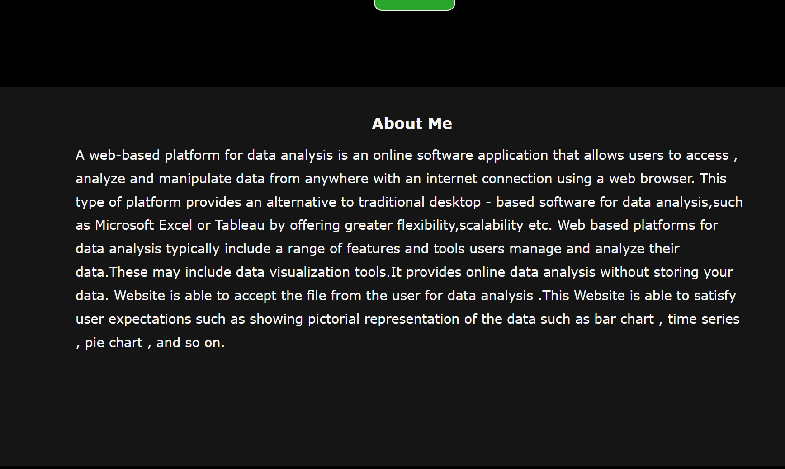

Front Page for About (index.html)

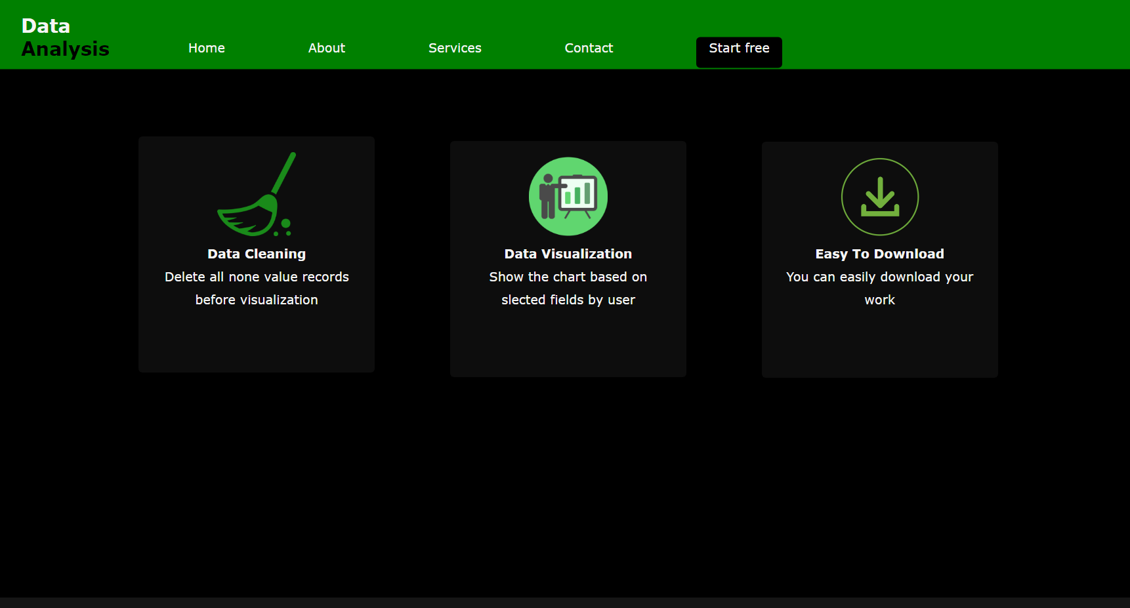

Front Page for Services (index.html)

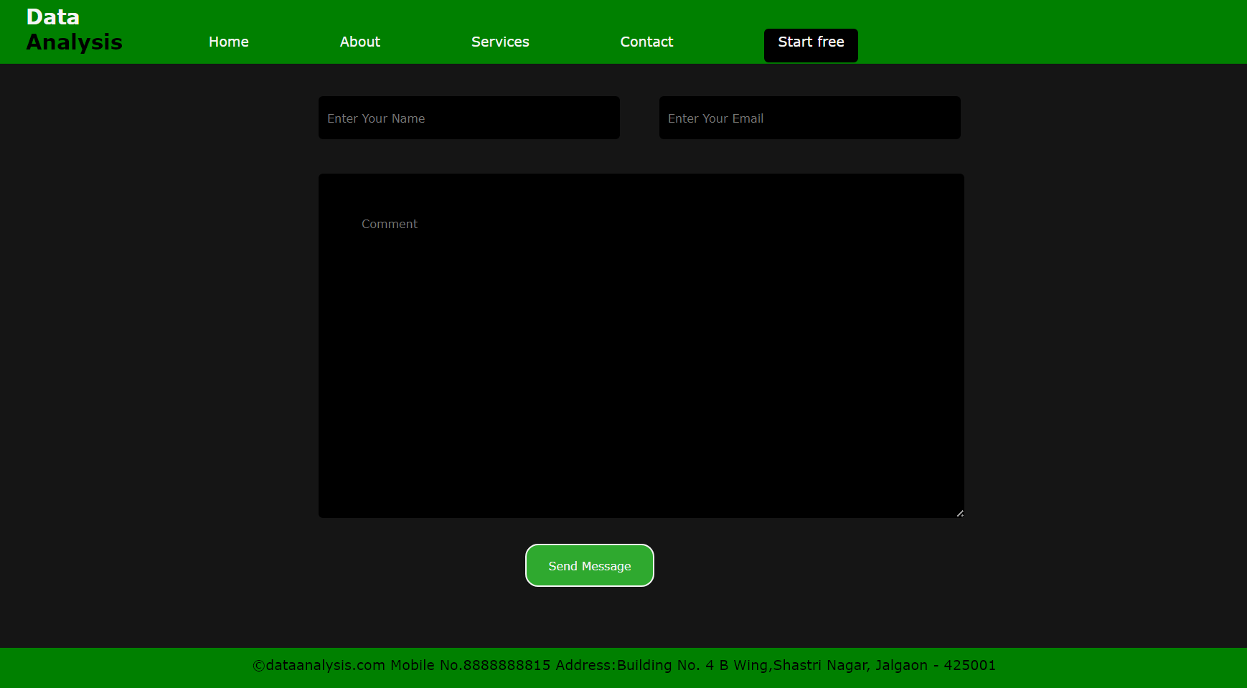

Front Page for Contact (index.html)

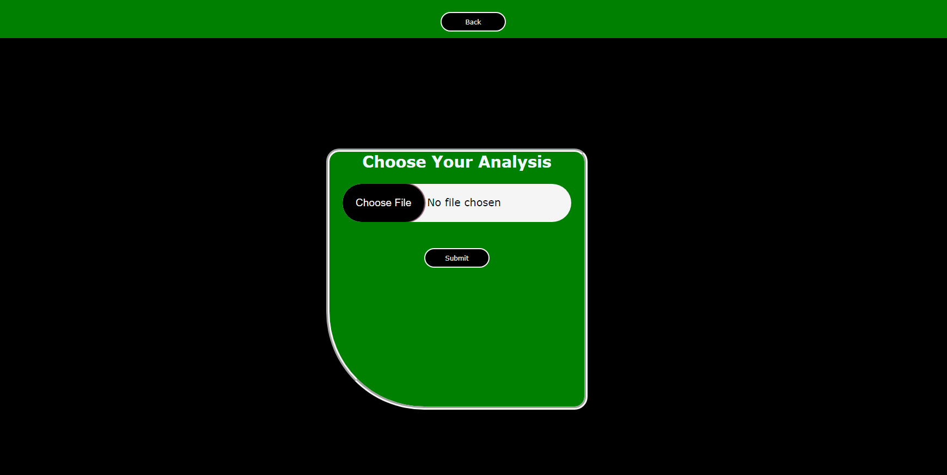

Page for File Upload (fileUpload.html)

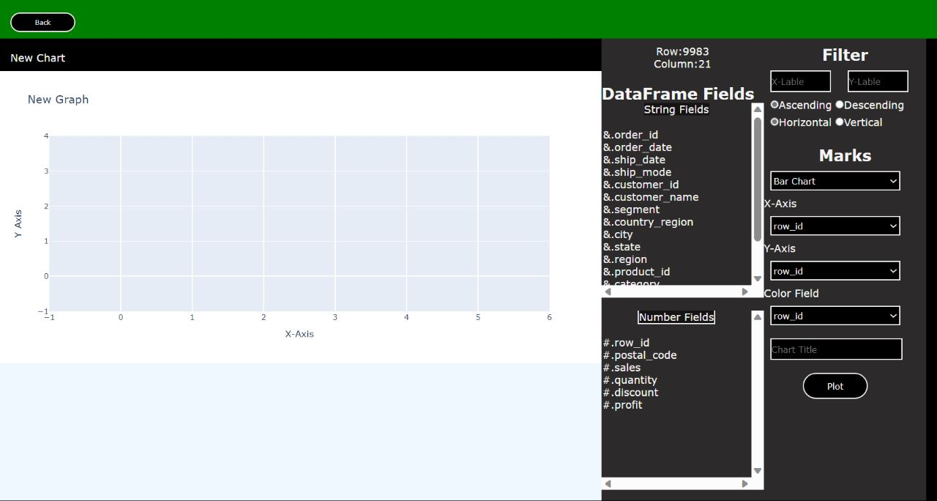

Page for Analysis (analysis.html)

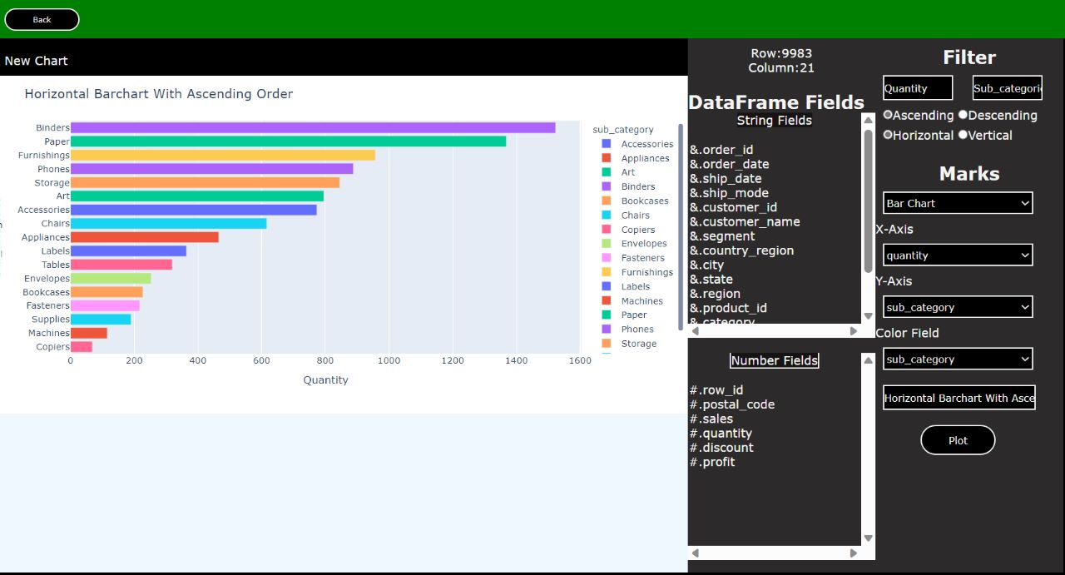

Horizontal Bar Chart (analysis.html)

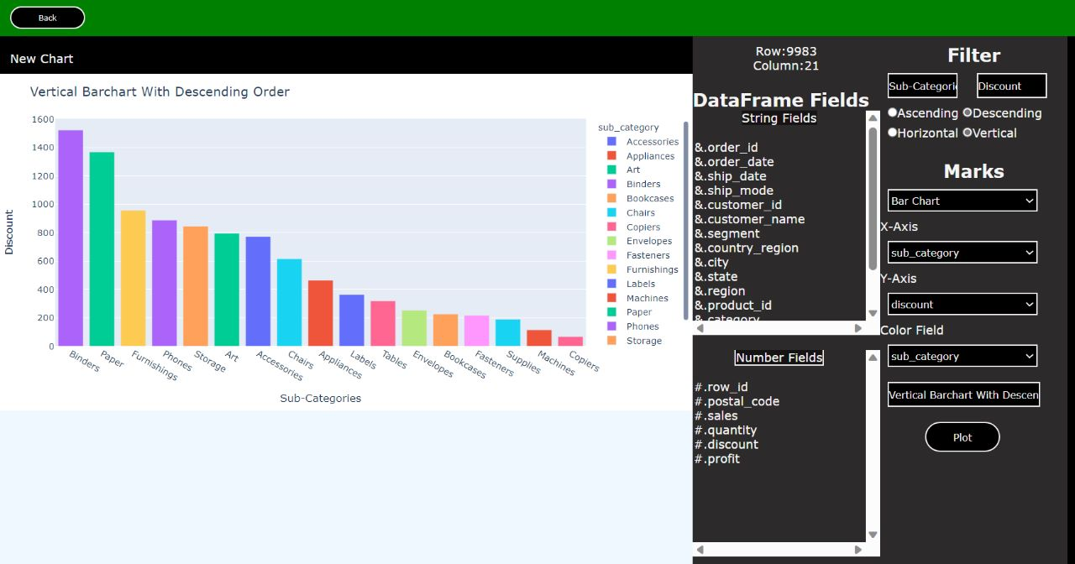

Vertical Bar Chart (analysis.html)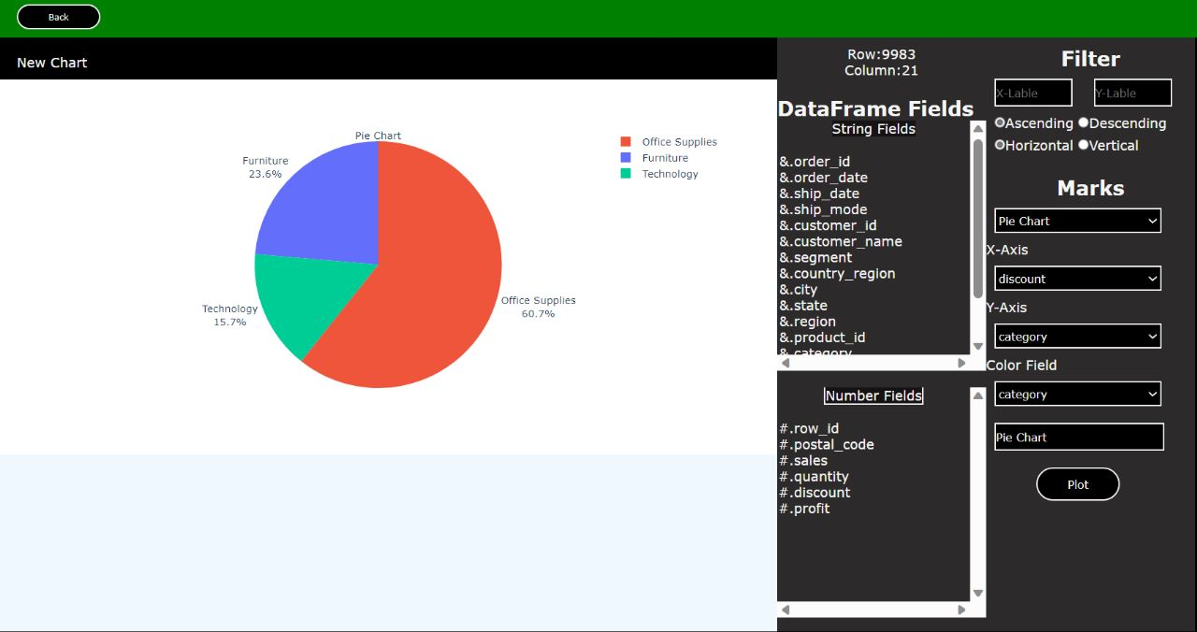 Pie Chart (analysis.html)

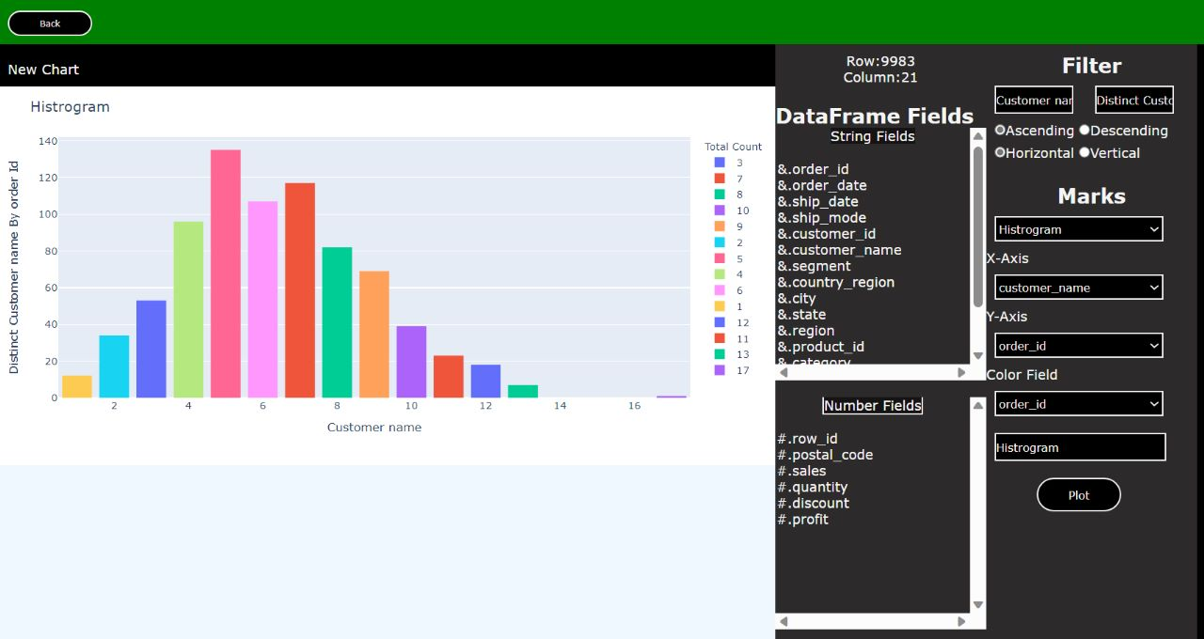

Histogram Chart (analysis.html)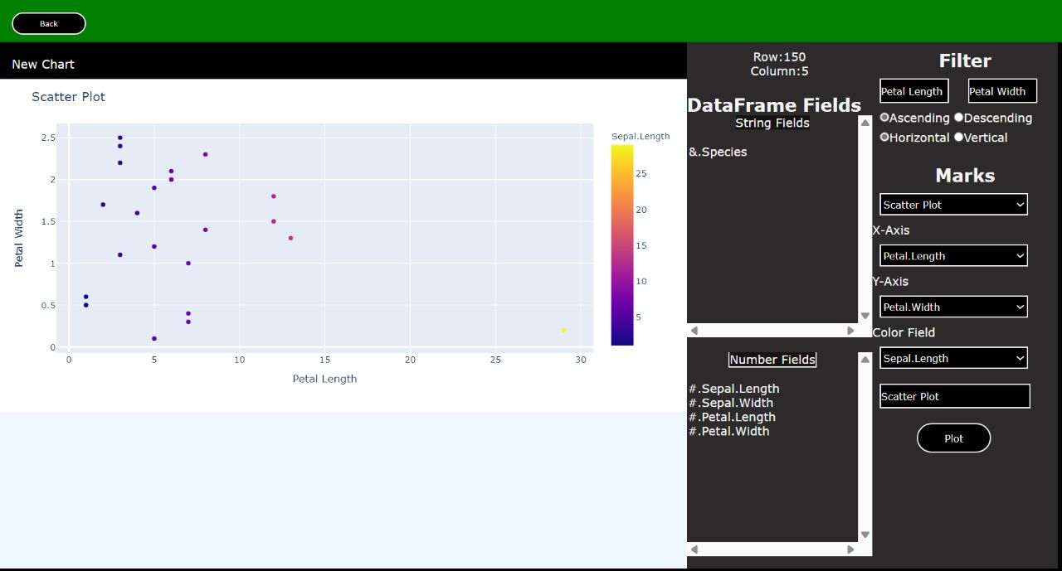

Scatter Plot (analysis.html)

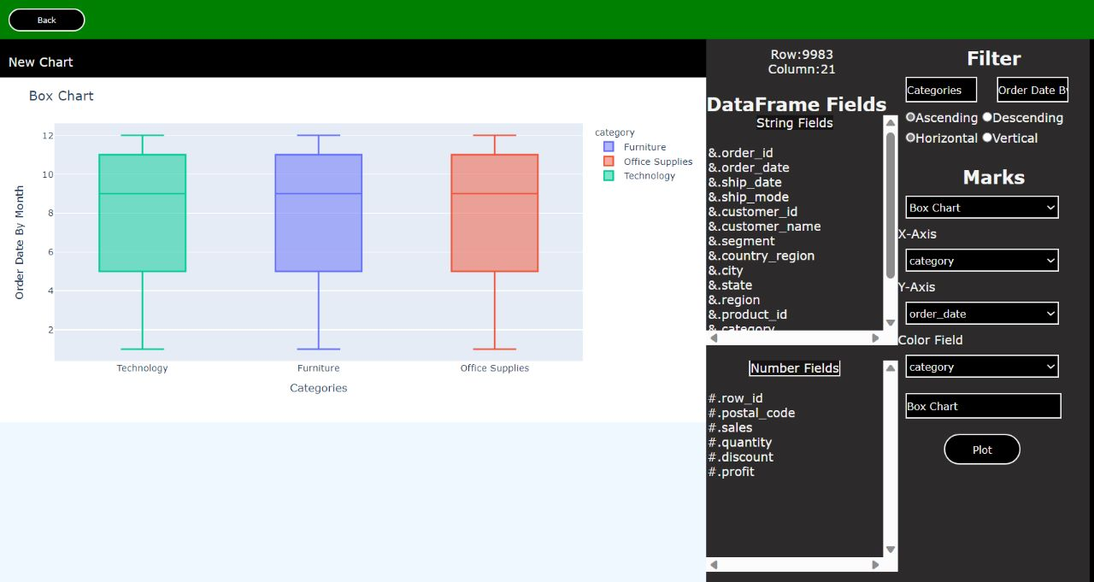Box Chart(analysis.html)

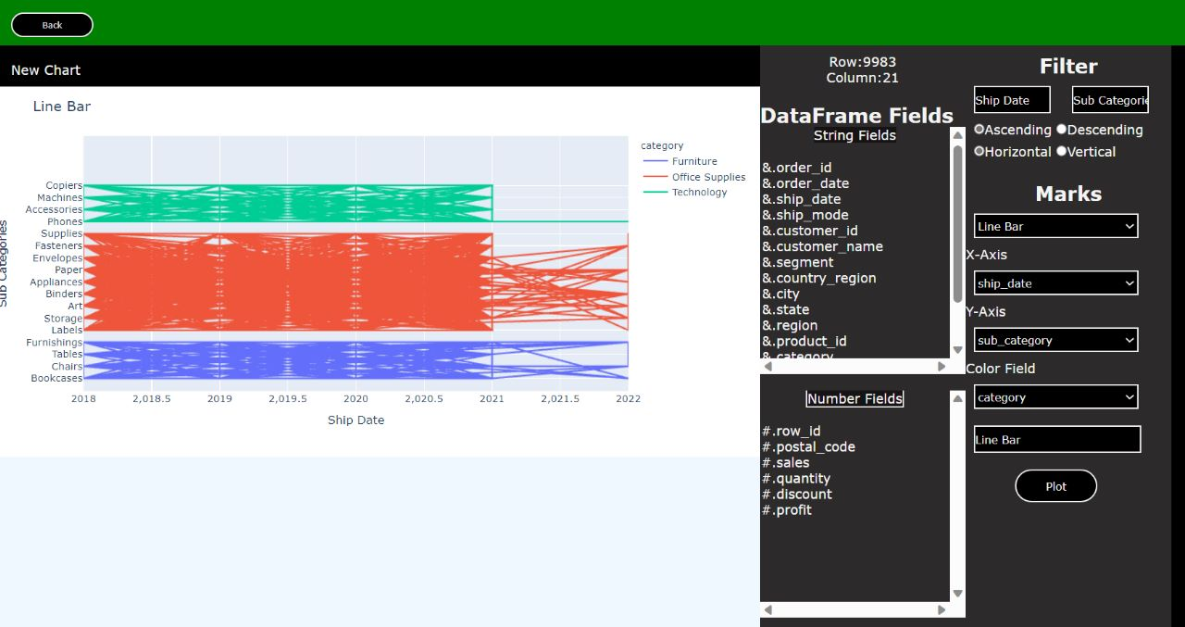

Line Chart(analysis.html)

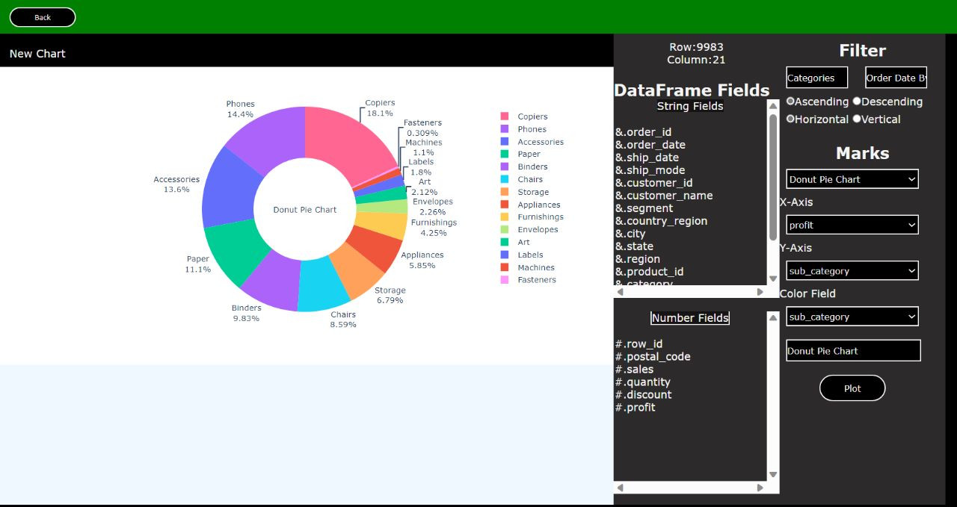

Donut Pie Chart(analysis.html)

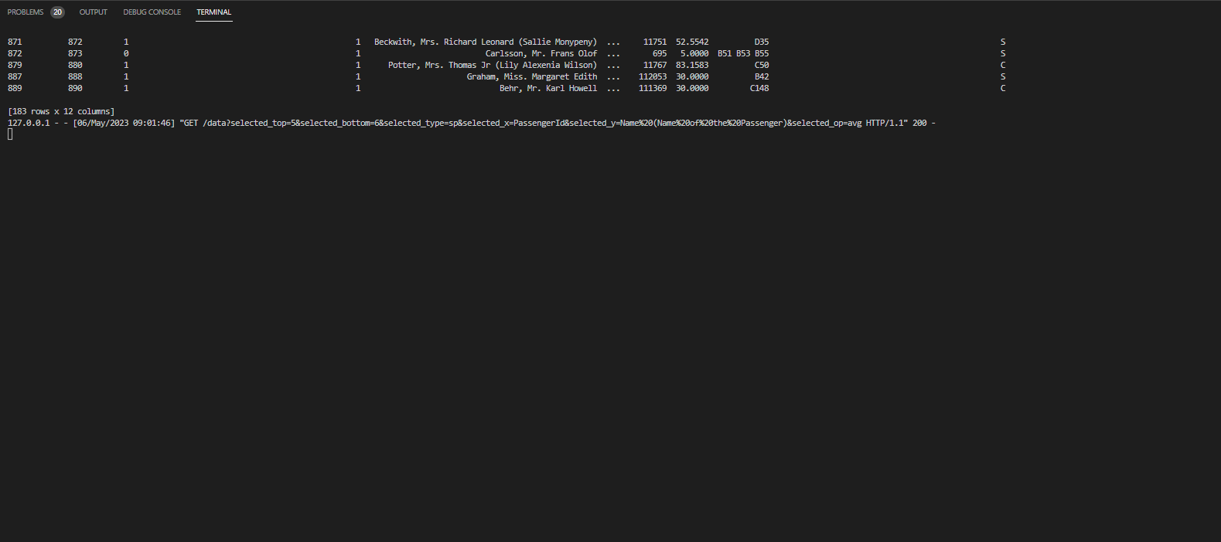

Data Send to Server